
Mission is Possible: Empowered by God

Women’s Ministry Sunday promotes and recognizes the many ways that women live out God’s mission in the church and community. Mission is possible when women and men, empowered by God, minister together, witnessing to the Gospel.


The love of Jesus calls us
In swiftly changing days,
To be God’s co-creators
In new and wondrous ways;
That God with men and women
May so transform the earth,
That love and peace and justice
May give God’s kingdom birth.
Anglican Church of Canada
Common Praise Hymnal #434 verse 4


Sunday

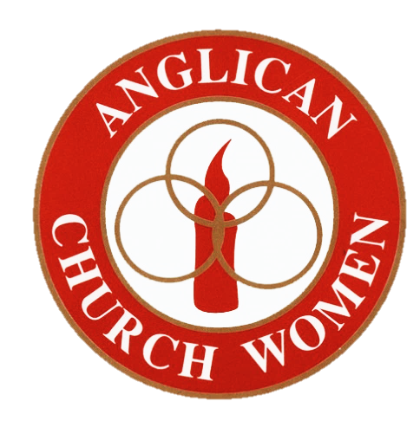
PRAYER FOR THE ANGLICAN CHURCH WOMEN, DIOCESE OF NS & PEI
Almighty God, we give thanks to you for having sent your blessed Son to become the Saviour of the world; grant to us a deep sense of gratitude for your grace and mercy towards us. Enable us by your Spirit to reveal your love in all our actions, so that your salvation may become known to all peoples and your name glorified throughout the earth; through Jesus Christ our Lord. Amen

Fourth Sunday
after Epiphany
Sunday, February 2nd 2020

Did you know? That the
Anglican Church Women Board:
DIOCESE OF NOVA SCOTIA & PRINCE EDWARD ISLAND

- Organizes annually a Lenten Quiet Day with AST students and their Formation Director, our ACW Board Chaplain, and hosting parish and a Faith & Fellowship Gathering, sometimes in partnership with the Diocesan Mothers’ Union, with a focus on spiritual development and missional leadership?
- Supports women in the parishes in their spiritual development and for their on-going ministry and range of social action, missional activities?
- Encourages regions in the diocese to hold a Regional Gathering for women to foster fellowship, provide a corporate worship service, and offer an educational opportunity?
- Provides leadership for the White Ribbon Campaign, in companionship with the International Anglican Women’s Network (IAWN) and the diocesan Mothers’ Union, to advocate for the physical safety and psychological security of girls and women worldwide?
- Promotes the continued development of Women’s Ministry Sunday when we honour the many ways that Anglican women, along with men, live out God’s mission in the church and community?
- Coordinates the sale of the Canadian Church Calendar campaign?
- Renews its membership each year in the Anglican Foundation and encourages others to do the same?
- Presents Kingston Memorial Fund bursaries to AST students and the Anniversary Bursary for continuing education to a deserving woman?
- Publishes 3 times a year our Newsletter, Keeping in Touch, recognizing its value to women and others here and elsewhere? Every parish should have at least one subscription.
- Writes a monthly column in The Diocesan Times?
- Operates each year with a theme? For 2019/20, as in 2018/19, the theme is Mission is Possible: Empowered by God.
- Sponsors and promotes yearly, an Annual Outreach Project (the projects alternate yearly from a local focus, to a national one, to an international one)? The internationally-focused Annual Project 2019/20, Education – a life changing gift is bringing in funds from the parishes and individuals in our diocese to support post-secondary education of orphaned youth in Kikima, Kenya who are being raised by their “Grannies”, with support from the “Grannies” in King’s Co., NS. We are delighted to be supporting the King’s Kikima Grannies and give thanks to all in our Diocese for their support of the Project.

