Begin Anew
Becoming Spiritually Mature through Prayer
February 10, 2019

1. Where are we without God? Do we just want what we want or do we want what God wants for us? Are we dependent upon Him or do we have all kinds of ideas and plans of our own about what we think is best?

2. If God knows everything – then why do we pray?

3. “Do we need to actually pray if we’ve made our needs and our thanks, for instance, known to each other in a group? I mean, ‘God’s been listening, He’s in the room… isn’t it kind of redundant to say the same things to God?’”

4. I would encourage you to pray to God for even more reasons:
- Because praying to God is more than therapeutic group-sharing
- Because praying to God gives us the chance to hear ourselves as we listen to Him
- Because praying to God is not praying to each other

5. Some times to pray…
- Pray at the beginning and the ending of our time of lectio divina
- Pray when we need forgiveness
- Pray when we are grateful
- Pray in times of need

6. How we might pray…
- Pray the model of the Lord’s Prayer (Mt. 6:9-15 and Lk. 11:1-13)
- Pray the Prayer of Relationship Ripples

7.
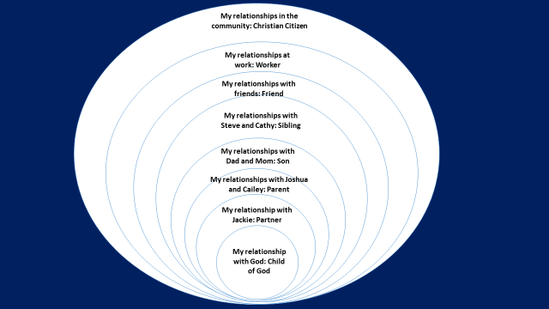

8. Pray the ACTS Acronym

9. ADORATION expresses our sincere affection and praise and respect to God for who He is.

10. Some descriptors of our Lord:
God Almighty
Nurturer
Gracious
All-knowing
Everywhere-present
All powerful
Provider
Forgiver
Teacher
Guide
Encourager
Giver of Peace
Comforter
Protector
Healer
Kind

11. CONFESSION agrees with God that we have sometimes missed His best for our lives by doing and saying things apart from His will.

12. Examine me, O God, and know my mind; test me, and discover my thoughts. Find out if there is any evil in me… (Ps. 139:23-24, GNT).

13. THANKSGIVING expresses our thankfulness to God for all that is good in our lives.

14. Here are some THANKSGIVING triggers:

- People who have blessed your life/impacted you positively

- What God has done in your life – with the gifts and opportunities He has given you – and the miracles of your days (good things that have happened inexplicably)

- Creation – the playground of earth and how it reveals the nature of God

- Your salvation, adoption, and eternal hope

- Family, friends, and special relationships

- The never-to-be-taken-for-granted basics of food, clothing, and shelter

15. SUPPLICATION is the act of asking our Father for our daily bread.

16. “Ask and it will be given to you… Which of you, if his son asks for bread, will give him a stone? Or if he asks for a fish, will give him a snake? If you, then, though you are evil, know how to give good gifts to your children, how much more will your Father in heaven give good gifts to those who ask him?”… Every good and perfect gift is from above, coming down from the Father of the heavenly lights (Mt. 7:9-11 ; Jas. 1:17).

