
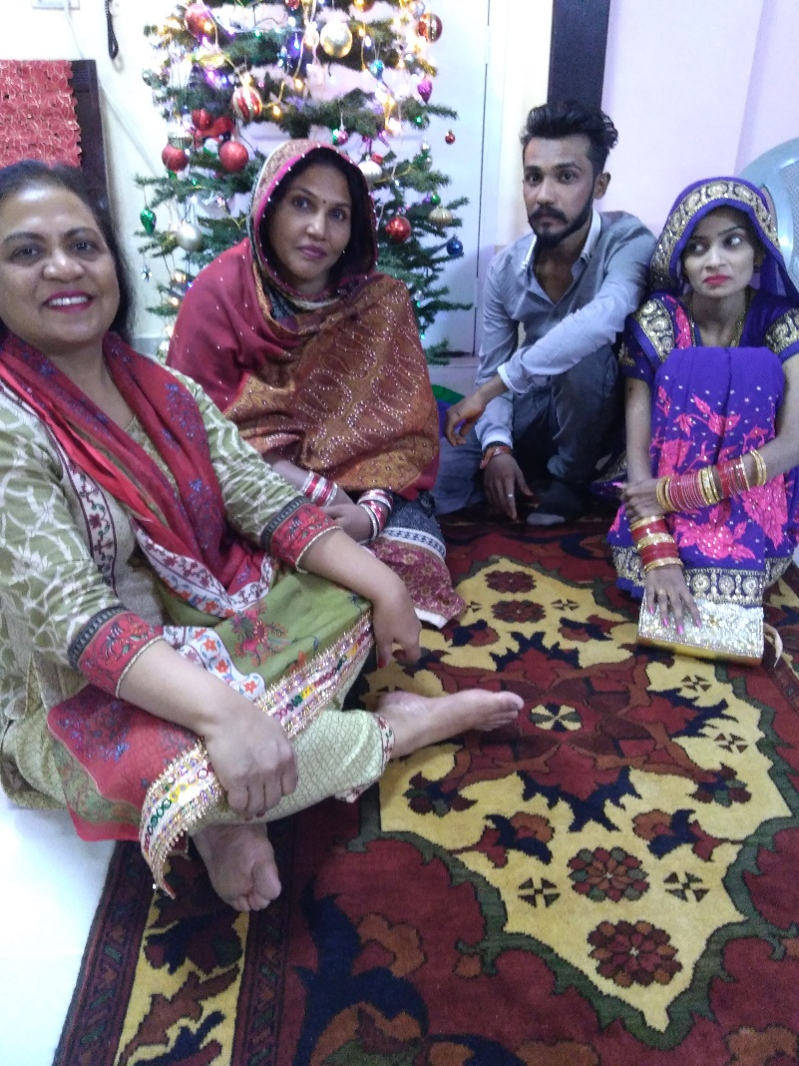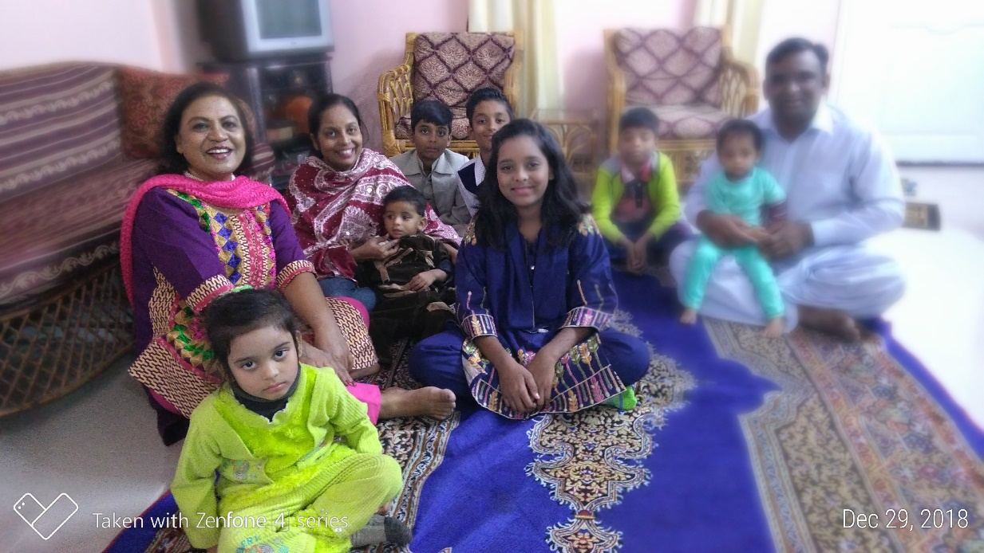

Merry Christmas and a Happy New year 2019

We have been blessed.

1. We feel God’s presence in our lives. The Joy of the Lord is with us where ever we go. Many times we can see very clearly He is going before us and protecting us from the street criminals and protecting us in a heavy traffic where there is lawlessness.
For the time being we have started inviting marginalized Hindu Marwaris family & M. convert and his wife with Seven Children. We celebrated Christmas with them and blessed them with Food packages. Jamila Sang some Christian songs in Urdu language and Nadeem Shared a small story of Christmas. For small gathering our apartment is good so far.

But we are still looking for a separate place for the further activities.
Thank you for your prayers that we all had peaceful Christmas in Pakistan.
We appreciate your support, prayers and concern.
Blessings and Love.
Nadeem and Jamila Qazi

