
PAKISTAN
News Letter No.7 January 2020
Dear Brothers and Sisters,
We both are doing fine by the grace of our Lord Jesus, we just suffered with Cold and flue. The weather is cold 6.5C which is very Cold for Karachi’s people. The North side of Pakistan is very cold and snowing, a lot of people died because of land sliding. Very sad.
We are continuing our Ladies Ministry and ESL/VBS Ministry for girls.
Please pray for Genuine Seekers:
A M friend 37 & his wife 25 showed interest to get to know the Word of God. We thank Lord Jesus whole heartedly for this wonderful opportunity to work for Majority group of people. Soon we will start sharing the Word of God with both of them. We would really appreciate your prayer for their commitment. They may come regularly.
A Single friend Landlord in contact with us.
A friend 60 years of age and his wife is a doctor are in touch with us. Please pray for them.
Good News that our daughter in Law in Holland got a good report from the doctors, another different test MRI and Ex-ray shows that the tumors are Shrinking and she doesn’t need pain killer injections but tablets only. Doctors are very optimistic and hoping for the best. Thanks for your prayers. Please keep continue uplifting Ida in your prayers.
We highly appreciate your Support and prayers for our Ministry and for our family.

Blessings and Love,
Nadeem and Jamila Qazi
FEB International Workers
Karachi Pakistan
North of Pakistan Quetta
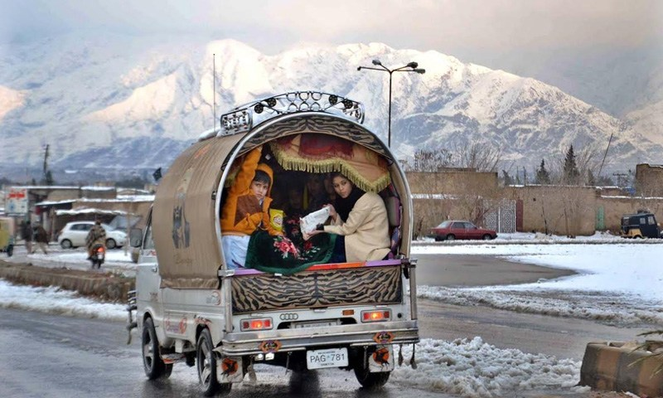
Karachi City


