Praying for CARDONAs in Colombia. (July, 2016)
We thank God, in the name of our Lord Jesus Christ, for all of you who pray for us!!!! Your prayers are so important for the daily challenges we face in our ministry every day. We thank you so much. Here you will find some prayer request. Blessings!!!

1. Please keep praying for the school of preachers. Among our churches here we train 50 godly believers who want to share the word of God faithfully. Beginning of June we had our annual retreat where they were tested on preaching publicly For most of them it is their first time in order to probe how they are growing their passion and skill for sharing the word of God. Pray for our school in each of the churches. They meet at least once a month. In same cases once a week! They are the base group of teachers for our churches.

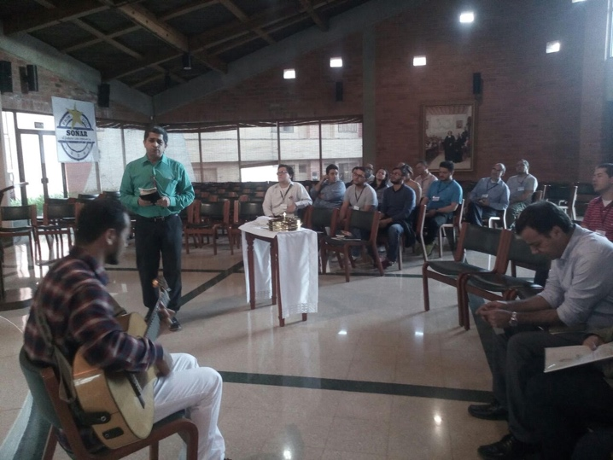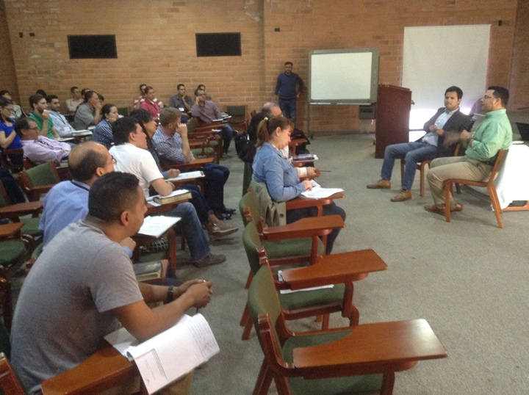
2. Middle of June we went to Guajira (the northern peninsula of Colombia). People die there for lack of water. We were there for a week with a group of 45 people doing humanitarian work as well as teaching and sharing the gospel.
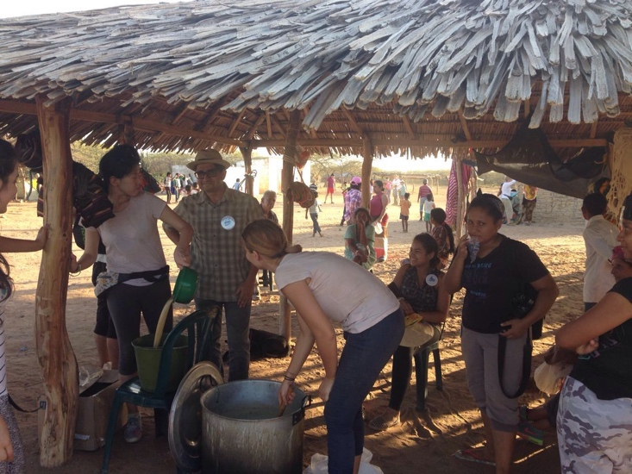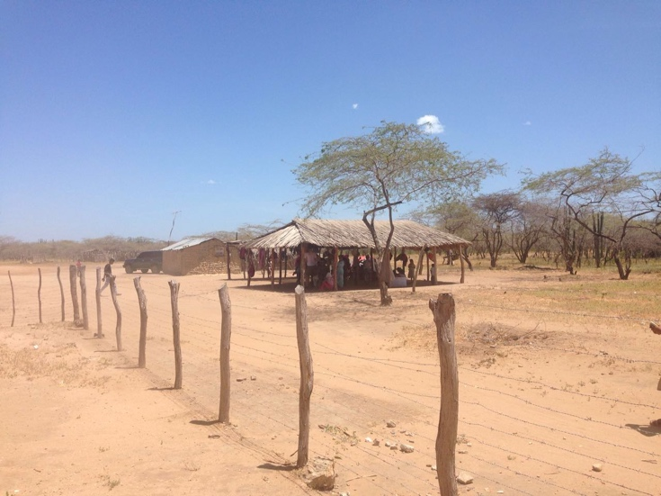

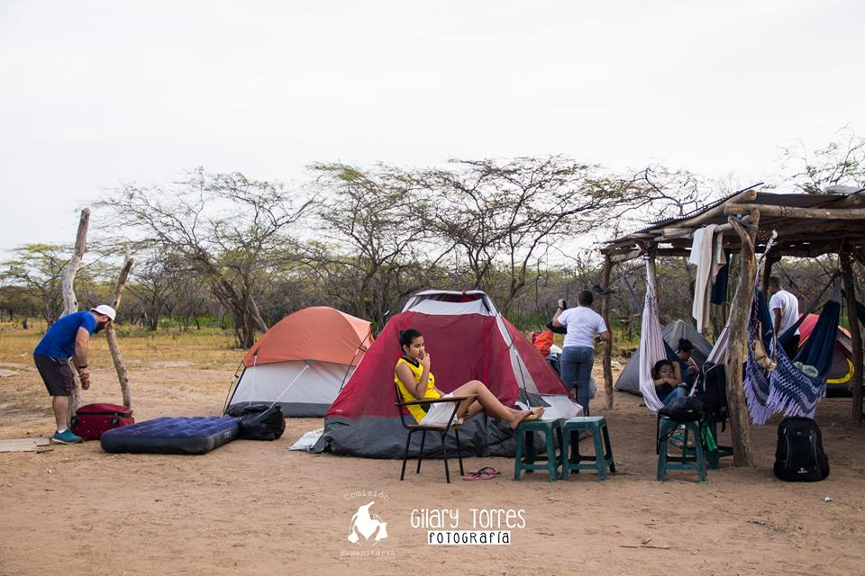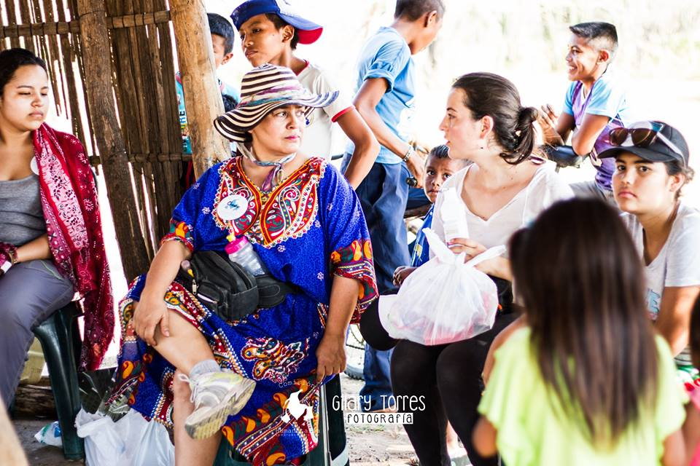

3. We have lots of opportunities to serve teaching expository preaching. This is a real probe of the need of sound teaching in the growing evangelical church of South America. Please join us in prayer so we can have the so needed discernment to understand what invitation attend in order to join our God in what He is doing through His word!
4. We oversee "El REDIL" churches. And we are heavily involved in El Redil Estadio a new (or renewed) growing church! We are so excited to have lots of young leaders and couples ready to serve. That brings us to our knees, please pray for this privilege of leading 2 of them in church planting, moving our churches in social work as well as missions. Pray for wisdom when that sincerely ask for guidance in their ministry as well as in their family life. Here we are baptizing a deaf girl, there were 20 people who got baptized last week and two of them are deaf. We praise God for that:
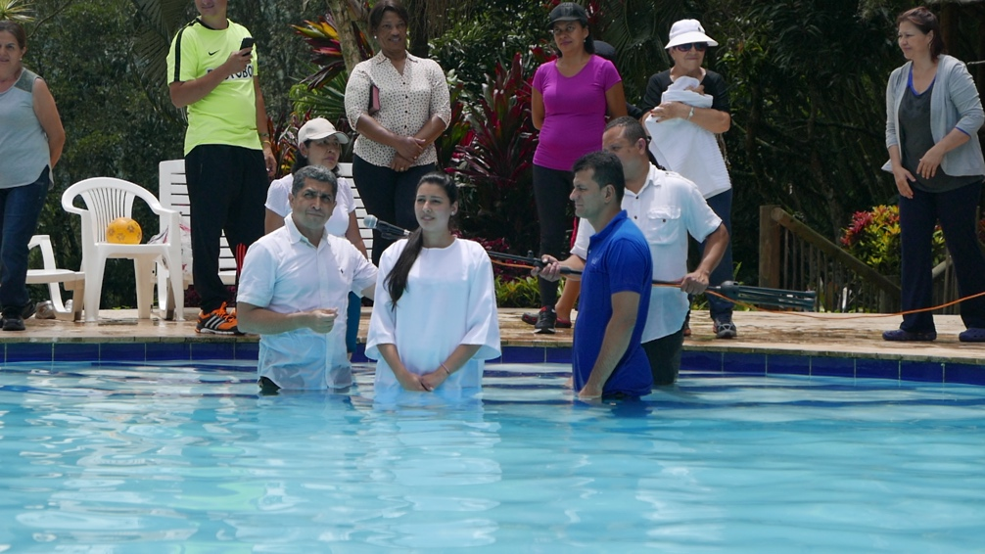
5. As a family we are doing well. Tania (now 24!) is half way of her second university career. Happy with her dancing and photography. On the other hand we are so excited having baby Lucas, our first grandson. Pray for this grandpa and grandma, that are so in love with this boy but have not enough time to enjoy it!!!
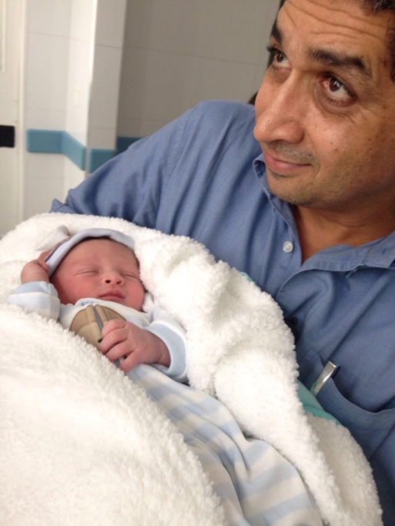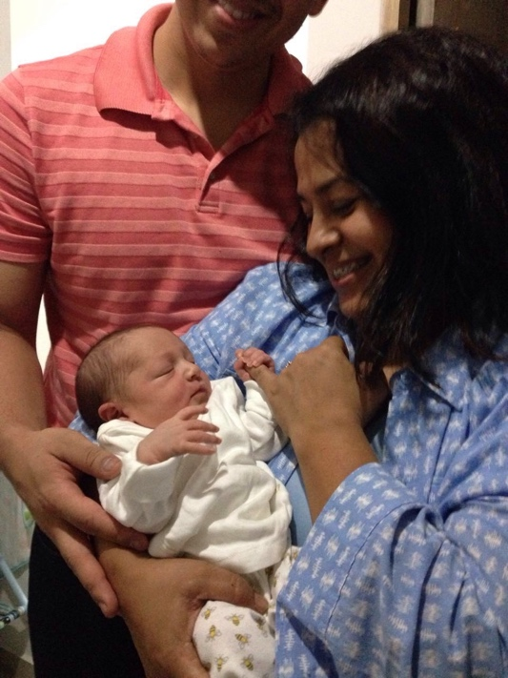
6. Diego just turn 50!!!! And besides feeling older, we need prayerfully consider our next step in ministry. It is not easy for us having such a great passion to serve in the midst of so many opportunities, to make decisions regarding the use of our time.

Thanks for being our partners in prayer.
Diego and Claudia.

