Cardona’s Prayer Letter, Jan. 2019.

Dear brothers and sisters in Christ, who support our missionary work and church planting in Medellin Colombia.

We write to you with great joy and gratitude, because we feel the support of God in response to your prayers. We remember you with great affection !!!

Last week we celebrated our 30th anniversary of marriage, and a few months ago we celebrated 20 years as Associate Missionaries with Fellowship International.

We continue to work hard to see the church of El Redil Estadio becoming a mother church and missionary sending church.

This month Marino and Adiela Sánchez begin to work 4 days a week in our new El Redil church plant in Copacabana (40 minutes north of Medellín). With great joy we see this new work and celebrate that every three years we are launching a new church plant for the glory of God.
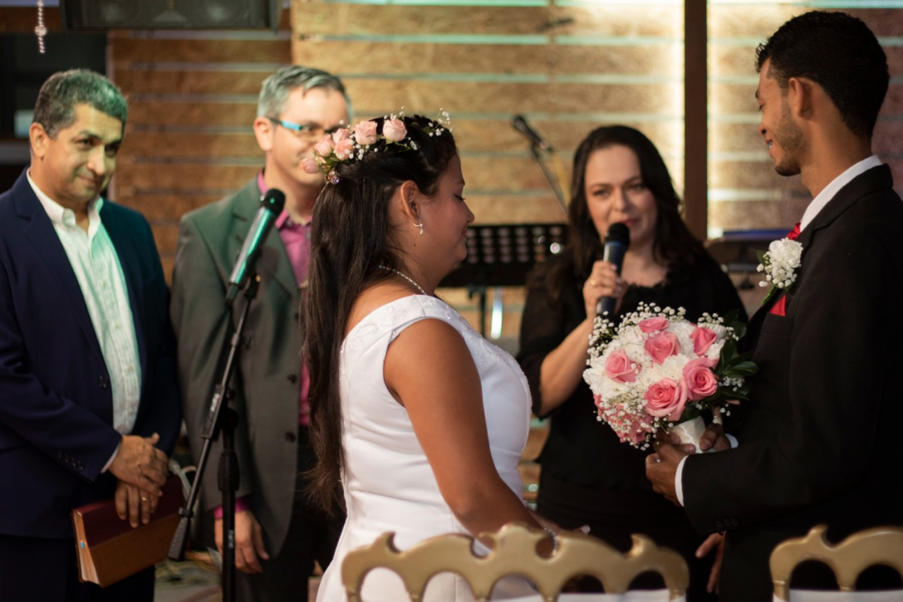
The work among the deaf could not be more exciting. In the attached photo I show you the wedding of a deaf couple performed by pastor Efraín Gallego and his wife Eliana. This photo requires more explanation to see God's blessing.

1. It is the first wedding performed by Pastor Efraín, whom I have been mentoring for three years. This accounts for his growth as a pastor. Efraín is starting this year his aspiration to a master degree with the IMMERSE program, from NorthWest Baptist. This is a source of joy and much prayer for this young pastor.

2. This is a deaf couple who have been converted to the Gospel under the ministry of El Redil Estadio. Victor and Victoria are a great testimony for their families and friends.

3. At the wedding, thanks to the sign language translation that several brothers rendered at the wedding, the families of Victor and Victoria (who do not communicate themselves by sign language) could hear the testimony of their lives transformed by Jesus Christ. This was a very exciting day for us, seeing the fruit of the ministry reaching more than 120 people who could see lives centered on the Gospel.

4. Deaf ministry has become a great blessing for our church. We have over 10 people in our church that have learned the sign language in our church during the las 3 years. This is a tremendous way of seeing reconciliation with this suffering community in Medellín. I feel so proud of Claudia, who now is almost totaly fluent in sign language.

5. For all of this, let us give glory to God.

Our family is doing well. The three grandchildren are growing and filling us with love and joy! We have had a run of respiratory diseases, due to changes in temperature and pollution in Medellín. We need your prayers for our health.

We thank God that we were saved in the middle of a car accident that we suffered when we were in Florida, USA, attending for few days the graduation of our oldest nephew. God manifested himself taking care of our lives in a very special way.

Announcement:

From April 22 to June 1, we will be visiting some churches and supporters in BC. We will not have time to visit all the churches on a Sunday, but we can certainly look for other moments to see all of you who live in the area. Our condition of national missionaries and associates does not allow us to take a whole year to visit the churches. We appreciate your prayers and your patience with us. We would also like to know about your availability to visit you during these weeks. God bless you.

Diego and Claudia.

Diego and Claudia Cardona
Associate Missionaries,
Fellowship International Ministries, Colombia
See our BLOG
Our church in Colombia
Cell (57) 311 315 7754
Send us a Bible verse or your greetings
through What'sapp

