October, 2018

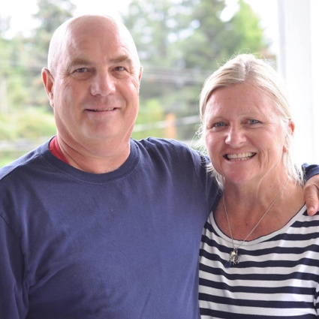

Hi Family & Friends,

We hope all is well with you.
Here is a Bueckert/ YWAM Hockey update.

NE ASIA
In July we were in one of the North East cities that we regularly visit for a 10 day hockey camp. There were about 50 kids from two countries. On this trip there were two other coaches along with me; Mark, my American friend, who lives fulltime in this country and has worked with me over the past 10 years and Colin a friend from my old hometown, Campbell River BC, who is a goaltender.

This was one of our best camps! The kids were very receptive to our on ice coaching and off ice we had the opportunity to speak of life experiences in our two Coaches Corners.

HOCKEY DTS & RUSSIA
September 25th was the start of our five month long Hockey Discipleship Training School (HDTS). We partner with YWAM Vancouver for this school as we have many times before. Our team is made up of 18-26 year olds from Switzerland, USA, and Canada - 8 young men, 1 young woman, and our staff guy, Adam from Nanaimo, BC.

We are heading into week 6 of Hockey DTS and our team is beginning to gel quite nicely. They have a busy schedule including lectures with a new speaker each week, work duties, outreach prep and of course on ice sessions and dryland. The lecture phase ends Dec 21 and we leave for Russia between Christmas & New Years. Our folks in Russia are already requesting that we come to their village or city.

Keep updated by checking out YWAM Hockey Facebook page.

Here is one of the notes that we have received about YWAM Hockey in Russia:

ZELENODOLSK-Feb 25,2017
Card from Nastia (pastor Andrey’s wife)
“Thank you for your big heart and unbelievable ministry! You’ve opened the new world for us. Your first visit had changed our life totally, it was in time we were exhausted (the church burned, the members left us, our sons were alone…) You were like the fresh breath for us.
…We are your fruits! Your example inspires us so much!”

FAMILY UPDATE:
Lorrain took a teaching position at a high school here in Richmond, which keeps her VERY busy!
Our oldest son Jesse is currently making a big life transition from working in the Caribbean over many years, to life here in Canada.
Nick, Lizzy and Jake (age 4) & Oliver (3) are a busy family in Victoria BC. The kids are playing hockey, soccer and swimming lessons. Never a dull moment with these precious boys!

PARTNER WITH US:
Please consider partnering with us through prayer and with finances ($4,000) to cover the Hockey DTS Russia outreach expenses for travel, housing, food and supplies for Glen.
Lorrain and I are very grateful for the generous support of our supporters.

You can partner with us financially by:
1) Mailing your cheque to YWAM Project Funding,
PO Box 57100, RPO East Hastings, Vancouver V5K 5G6
Please include a note that it is for YWAM Hockey for Glen’s Russia expenses.

2) CREDIT CARD/ DEBIT/ PAYPAL:
Click on this link to the YWAM Project Funding page on Canada Helps:
https://www.canadahelps.org/en/charities/ywam-project-funding/
Put in your donation amount and type, ”Donation for “YWAM Hockey” in the message box and then click on the Continue with my Donation for the rest of your info.

You will receive a tax receipt with any method of payment. Thank you!
Thank you for your continued interest and support! God bless!

Glen & Lorrain Bueckert
Founders/ Directors
YWAM Hockey
ywamhockey.com

Integrity - Respect - Character

