E T H NO S
FOUNDED December 4, 2018
IN 1942 AS NEW TRIBES MISSION
Dewar Family Newsletter

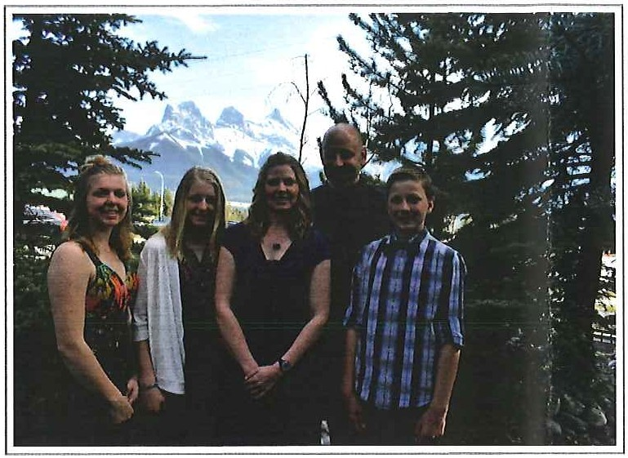Directing the work among the least reached people groups in Canada 's north


Contact us:
kendewar@ethnos.ca debbiedewar@ethnos.ca
519-387-9600 (Ken's cell)

313363 Hwy 6 South PO Box 707

Durham, ON. N oG1Ro

https://ethnos.ca/missionaries/ken-and-debbie-dewar/

Merry Christmas and a Happy New Year!
We hope this letter find you and your family well and enjoying the joyous season that is upon us.

We have had a whirl-wind of a year but we are so grateful that our Lord has brought us through it with His strength.Our ministry with FirstStory is still evolving. So far we have had to wear many hats as there has been many things to do in order to get FirstStory "off-the-ground" and Ethnos' new field of Canada operational. Lately, Ken has been occupied with speaking engagements to spread the word about the ministry needs in order to help recruit missionaries. We are so excited that there are many people who, although still in training, are now prayerfully considering Northern Canada for their future place of service. So far there are three families and one single gal who have already committed to going up North to the least reached in Canada and are planning on being here in January to start their orientation to the field. These missionaries have already completed their Cross-Cultural mission training with Ethnos and have been obedient to the call on their lives to go to the hard places for the sake of the Gospel. This is an exciting time.

We are happy to report that things are coming together to receive this first intake of missionaries! This is a first for Ethnos Canada but has been a long time in the making, we are thankful that we can be a part of it. The increase in missionary interest has kept Debbie occupied with the details for setting up the application and hiring process for what now is a "receiving field" for Ethnos Canada as well as the details for bringing foreigners into Canada as all of these first missionaries are coming from other countries. These are just some of the areas that a new field has to set up and therefore it has been a bit of a learning curve. We are so thankful that we have an immigration lawyer to work with and the personnel department of Ethnos Canada so close by.

December 4, 2018

What 's next...
In the New year (and the rest of December) we will be busy preparing for the start of orientation for the new missionaries. Co-workers of ours have been working hard on preparing the overview of what needs to be included and we will need to work together in order to get it ready to implement. Please pray for us and our team as we prepare for our first group of missionaries.

The new missionary orientation will begin in February. There will be a lot going on that month as well as the following months as we help prepare our missionaries for serving in the remote, isolated north. Please pray for these missionaries as well as us and the other leaders as we work together in preparation, team formation and location assignments. We are so excited to think that 2019 may be the year our first team is in a location and starting the work needed to communicate the Gospel clearly to those who so desperately need it. There is an urgency to the task of reaching the least reached but we can't underestimate the need for adequate spiritual, mental, emotional and physical preparation. We thank the Lord for His guidance in all of this.

On a personal note...
We have moved into our new house which is located much closer to the campus and our office. Already we have noticed a difference in the amount of gas we use and the kids are happy to be able to be more involved in the activities that go on during the week there. We thank the Lord for providing this place for us and look forward to seeing how the Lord will use this place for our ministry and His glory.

Kendra is enjoying Bible College but is excited when she gets to come home for visits. It's nice that she is only a few hours away to make it possible for more visits. Our family is looking forward to spending Christmas together here without any traveling. We will be able to share the time with some students that are unable to make it home for Christmas. We look forward to that also.

We feel truly blessed to have so many friends and family who have been obedient to the Lord in being a part of this ministry with prayer support and financial support. Both are very much needed and make it possible for us to do what the Lord has called us to do. We only have one life to live and are thankful that we are able to live it for Him. The sacrifices that have been made along the way do not compare to the sacrifice that was made for us when Christ came down, dwelt among us and took our place on the cross so that we could be saved. This is truly the reason for the season and we can't wait until the day when, "...a great multitude that no one will be able to count, from every nation, tribe, people and language, will be standing before the throne ...[crying] out in a loud voice: 'Salvation belongs to our God, who sits on the throne and to the Lamb'..." (Revelations 7:9 NIV)

Blessings to you and your family! Love,
The Dewar Family

2

