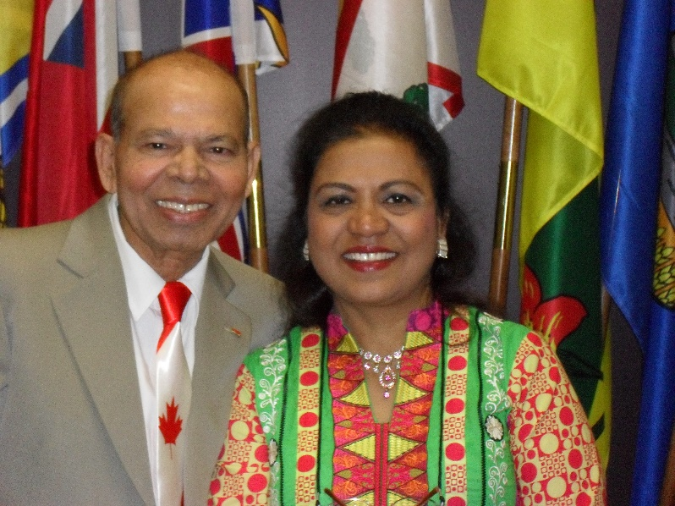

Prayer Letter No. One
Nadeem and Jamila Qazi October 2018

Dear brothers and Sisters. Thanks for your prayers. God made it possible for us to be in our home land. We got settled in finally. There were few issues in our apartment now it’s worked out well.
We have now filtered clean water to drink. Electricity is better than few areas. We are glad to be here in a huge city Karachi.

There are loads of opportunities to serve among nations. We are looking for a place where we could have a Cool Corner for kids and Women where we could arrange multiple activities. There are few particular and obvious reasons we could not just jumped in. Very carefully and intelligently looking for a safe place and easy access for everyone. We really appreciate your prayers for a Community Center.
We met many M. friends in our neighborhood who warmly welcomed us for the Dinner at 9:30p.m. We met our brothers and Sisters too on Sunday’s Service.
We greatly appreciated by some brothers and Sisters who are already serving.

We found a good hospital and doctor close to our Apartment. Thank God.
Our health is good. We rested and now we are good to go for further plans.
Pleased keep praying for us that we may find those who are in need to seek His face.
City Street Crimes are quite less now then it’s used to be. Thank God.
We travelled carefully in the Day light.
Weather is still hot during the day 40 degree. our old AC is working thank God.
We appreciate your support and diligent prayers.
We are whole heartedly thankful to you.
Blessings,
Nadeem and Jamila Qazi

Our Cell 001-92-3302564882
Email: njqazi@fellowship.ca
Skype: Aslam.qazi7

Heading 1
To replace the placeholder text on this page, you can just select it all and then start typing. But don’t do that just yet!
First check out a few tips to help you quickly format your report. You might be amazed at how easy it is.
- Need a heading? On the Home tab, in the Styles gallery, just click the heading style you want.
- Notice other styles in that gallery as well, such as for a quote, a numbered list, or a bulleted list like this one.
- For best results when selecting text to copy or edit, don’t include space to the left or right of the characters in your selection.

Heading 2
You might like the photo on the cover page as much as we do, but if it’s not ideal for your report, it’s easy to replace it with your own.
Just delete the placeholder picture. Then, on the Insert tab, click Picture to select one from your files.

