Cardonas Prayer Letter, Dec. 2019.
¡FELIZ NAVIDAD! Merry Christmas from Colombia!
The reality of the Incarnation of the Son of God fills us with joy at the thought that Jesus Christ, after living a perfect life, dying, and resurrecting is sitting on the throne to have compassion on us and transform us into His image. Claudia and I have been very inspired by the phrase that says: "Christmas makes sense when the cross emerges from the manger!" This is the gospel we preach in Colombia, full of celebrations that (as in Canada) try to hide the true reality of Christ-mas!
As you know, Claudia and I live doing many things, running from one place to another helping the churches and pastors, mobilizing them to church planting, social work, missionary work, ministry for the deaf, pastoring a 600+ church, and other things!
But it is time to stop and reflect on the greatness of Christ, His supremacy over all! He, who was born in Bethlehem, is our sovereign Savior and Lord, our beloved Master and Healer, the King of kings and Lord of lords!
While praising God for this year, we want to thank the Lord for your support in our ministry. You are in our prayers permanently, since you are our partners and friends in everything we do for the glory of God in Colombia. You may not have noticed, but you are in Colombia through all the things we do! God has blessed us greatly in recent years. The Lord has allowed us to see churches growing, and leaders being empowered for the work. God has kept His promises and He has provided everything necessary. Our Churches are reaching out helping the thousands of Venezuelans arriving in our city. And we are overwhelmed with joy to be able to minister to the deaf community in Medellín (over 20.000, around 40 are now coming regularly to our church!). We also have the privilege to see a growing ministry to the elderly that live in our neighborhood. Our God is good, good in a great way.
Thank you very much for remaining praying for us, your prayer support is a tool, really "The tool" that God uses to bring glory to his name as more souls are brought to the feet of Christ to be saved and sanctified.
The year 2020 will be a great challenge for our ministry. We have been guided by God towards a year of much espiritual formation of our churches (15 now) and of El Redil Estadio (the central church for our ministry) to develop the leaders that are required for the next church planting projects (we have just launched the new Copacabana church, and we are already studying the new region where God wants us to start a new church.) We will also continue to train about 40 leaders who feel called by God to missionary work, and to social and humanitarian work, especially towards venezuelan refugies. We will continue with the students of Immerse (master's program in which we have 6 people from our churches), and we want to introduce Leaders Formation and the International School Project to promote what in Fellowship International we call Disciple Making Movement.
Please continue to pray for us. Pray for our family: Daniel (our son, 29) and Sarah (his wife), with his wonderful three boys, and for Tania (27), so they continue to grow in their walk with the Lord. We also ask for your prayers regarding our financial support, we are still 15% down in our monthly support. We know that our God is faithful, and He will work through our prayers!
We know that we are small for the work that God wants to do in and through us, but this is not based on who we are but on Who He is !!!!
This Christmas, when we remember that our good God became man to have compassion on his people and bring salvation, we want to thank you for all your support and your love in Christ.
Diego and Claudia Cardona.
Fellowship International, Colombia.
diegocardonaq@gmail.com or cardonascolombia@gmail.com
PD: Please let us know your (new) email address if you are not recieving our prayer letter quarterly. You can also contact us by a text message using +57 3113157754 (“Whatsapp”, an free mobil app, is very popular in Colombia. We would love to hear from you, and to pray especifically for your family.
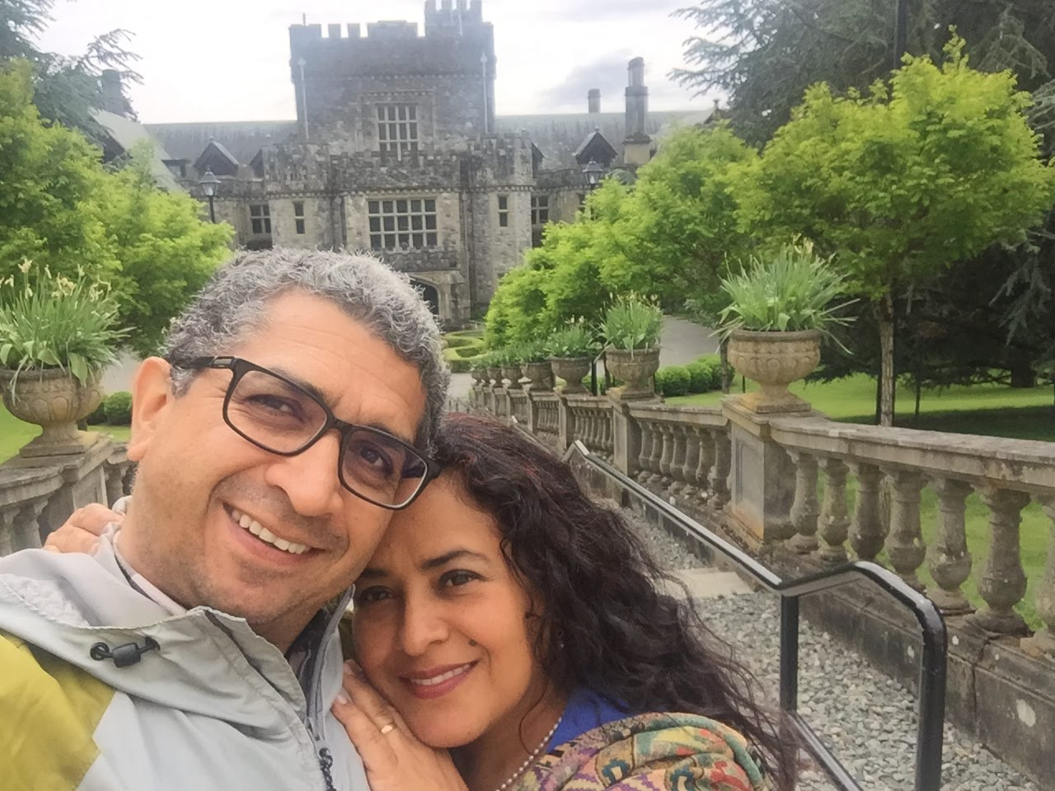

Our son Daniel with Sara and
their kids: Emiliano (12)
Lucas (3,5), Miguel (1,6)
these little ones
have changed our lives!
Our time in Canada this year, visiting churches, was a real blessing. We miss to see some of you
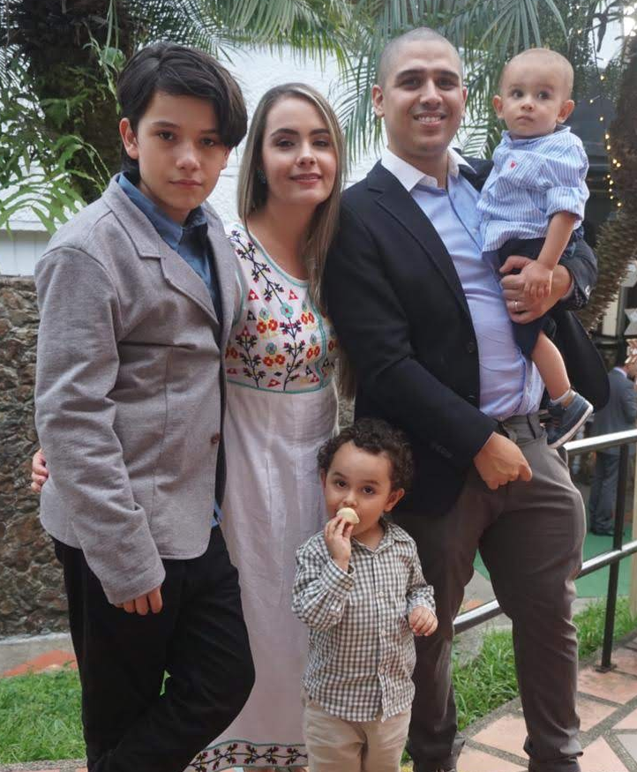
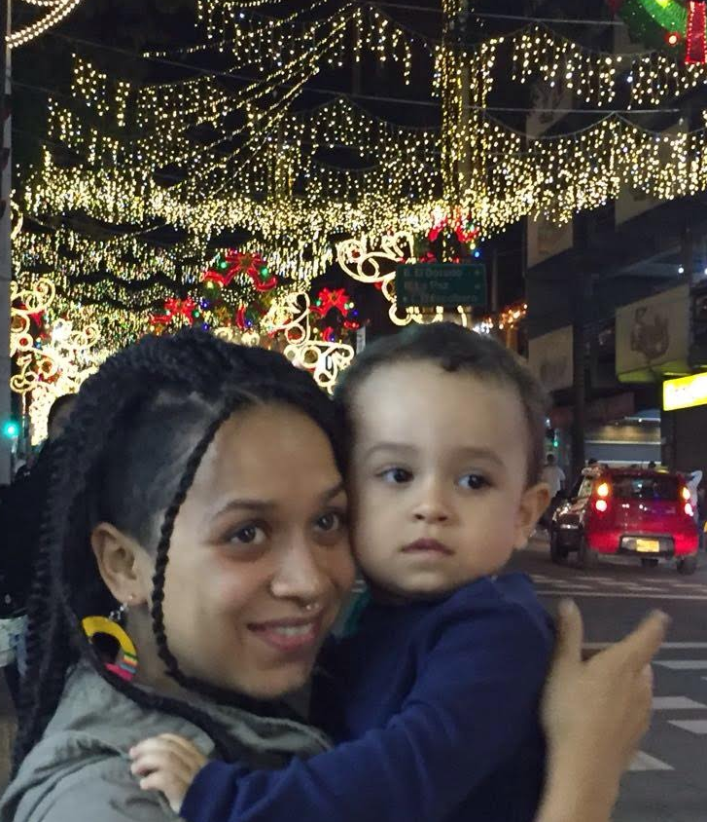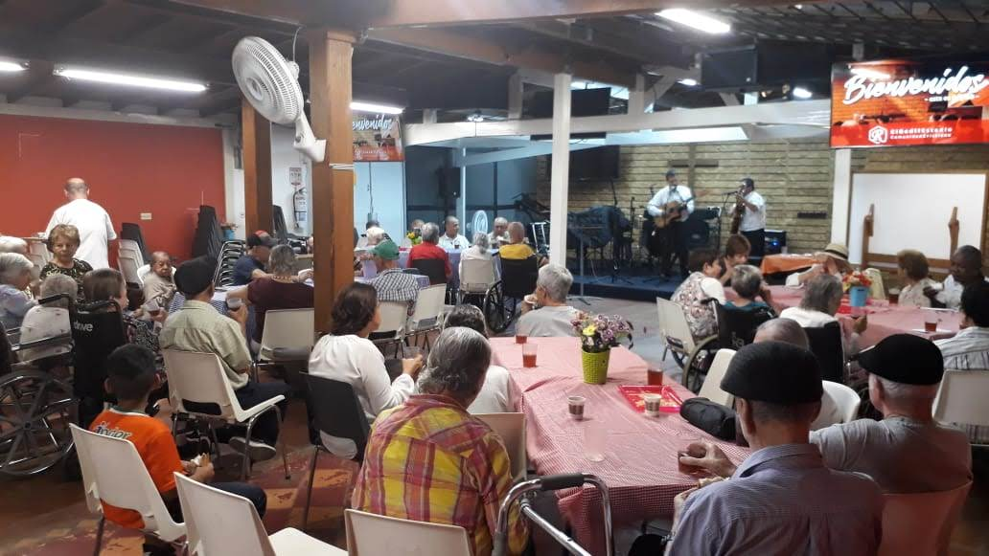
Our daughter, Tania, the most happy aunt
Ministry to the elderly from elderly homes close to Redil Estadio church

