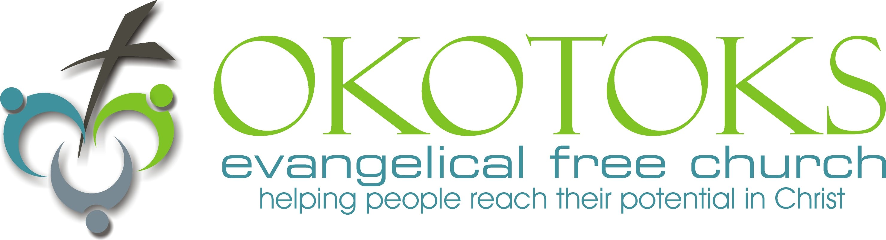
Even though our P to S don’t change
… our A to O them does

1. What does the bible say about homosexuality?

Leviticus 20:13 (18:22)

1Corinthians 6:9 (1Timothy 1:10)

Romans 1:24-27

2. What C_________ do we have against our S__________ P_____________?

1Corinthians 6:11

Romans 6:19-21

What do I need to do with what I have heard today?

Oct. 18, 2015 Sermon Notes What does the Bible say about Homosexuality?

Doing Life Together
10. Is there any gap between how you are now living and how you know God wants you to live? What next step will you take to bridge this gap? What will you need to stop doing?

11. What responsibility does our growth group have to push one another toward righteousness? How can we do that this week?

Prayer Requests

GROWTH GROUP HOMEWORK
October 18, 2015
Thinking things through
1. In the sermon this weekend, George helped clarify what the Bible really says about homosexuality. What is one point from the sermon that particularly challenged or encouraged you?

Digging Deeper
read Romans 6:1-11.
2. Paul began his letter to the Romans by describing the devastating impact the fall had on humanity (Rom. 1:18-32). According to Romans 6:1-11 (especially vv. 6-11), what happens to our rebellious drive toward sin (sin nature) when we become Christians?

3. What do you think it means to count yourself alive to God (v. 11)? What does that look like when lived out in daily life?

read Romans 6:12-14.
4. What is the connection between “count yourselves” in verse 11 and the choice Paul is calling his readers to make in verses 12-14?

5. Why doesn’t sin have to rule over us? What does it mean to live under grace rather than under law?

6. What would it look like for our bodies and their parts to be instruments (or weapons) for righteousness? How do we offer ourselves to God? Do you have anyone in your life who encourages you toward righteousness and away from sin?

read Romans 6:15-23.
7. In Romans 6:15-23, Paul used slavery imagery to depict living for God. How does obedience to sin end up enslaving people? What do we get in return for obeying sin as a master (vv. 19-21)?

8. What are the benefits and rewards of being slaves of obedience to God (vv. 21-23)? Do we reap these rewards only in the future, or do we benefit today as well? Explain.

9. Paul urged his readers to present themselves as slaves to righteousness rather than sin (v. 19). How do we do this day in and day out? What will this look like in daily activities such as our leisure time, browsing habits, spending, driving, speaking, and working?

Leader: Although one of the themes of the Christian life is freedom, it is not a freedom that brings the right to live as we please. That led only to sin and grief. Christian freedom is freedom from sin in order to live for God. We are always serving someone or something. To offer oneself as a slave to sin leads to death; to serve the Lord in Christlike living is the way of righteousness. Because Christ has set us free from sin and the law, our clear choice is to offer ourselves as slaves to God, leading to sanctification and eternal life. We present ourselves as slaves to righteousness when we pursue God’s will for our lives and live a lifestyle of obedience to Him. Only through the power of the Holy Spirit is this way of living possible for us.

DOING LIFE TOGETHER Help your group identify how the truths from the Scripture passage apply directly to their lives.
10. Is there any gap between how you are now living and how you know God wants you to live? What next step will you take to bridge this gap? What will you need to stop doing?
11. What responsibility does our growth group have to push one another toward righteousness? How can we do that this week?

What do I need to do with what I have heard today?

