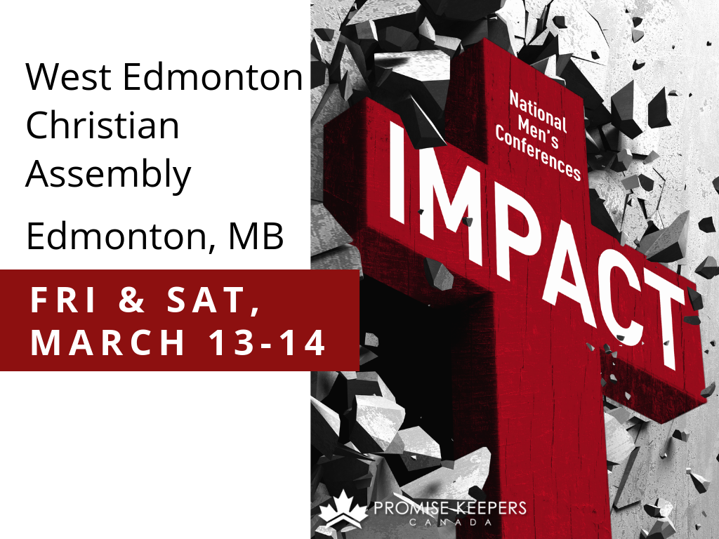
Registration Deadline
February 25, 2020
PROMISE KEEPERS CANADA
Registration Fees
Individual $75
Group of 6 – 9 men $65 each (1 free ticket with group registration)
Group of 10+ men $55 each (1 free ticket with group registration
Youth 19 years old or younger $40

Optional: Lunch Special – BBQ beef on a bun, potato salad and bottled water/pop $12

West Edmonton Christian Assembly
6315 199 Street NW
Edmonton, AB

Please see Randy Kadatz
or Text 780-865-8030

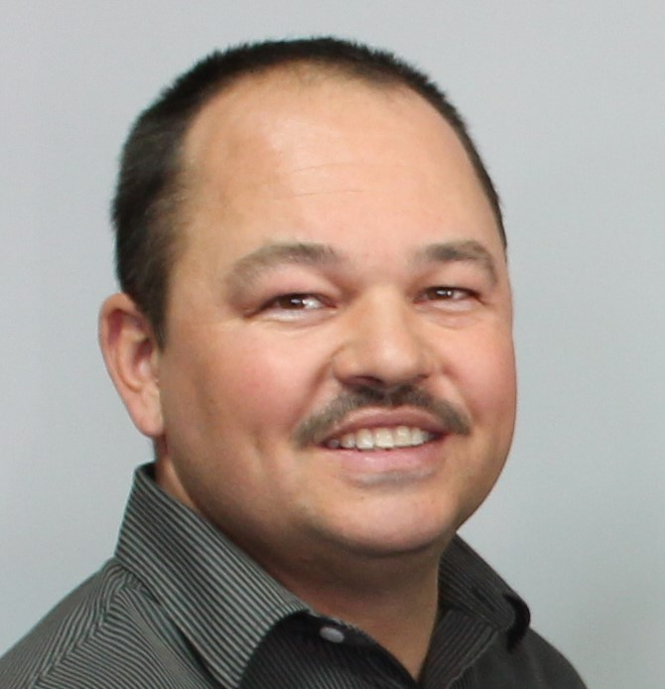

Agenda

Friday, March 13, 2020
6:15 pm Doors Open
7:00-8:15 pm Music and Session 1: Todd Petkau
8:15-8:40 pm Break
8:40-10:00 pm Music and Session 2: The Skit Guys

Saturday, March 14, 2020
8:15 am Doors Open
8:45-10:05 am Music and Session 1: Dwayne Cline
10:05-10:30 am Break
10:30-11:45 am Music and Session 2: Bill Farrel
11:45 am-1:00 pm Lunch Break
1:00-2:35 pm Music and Main Session 3: Kirk Giles
1:30-2:35 pm Youth Breakout Session: Mike Gordon
2:35-3:00 pm Break
3:00- 4:45 pm Music and Session 4: Steve McCready

