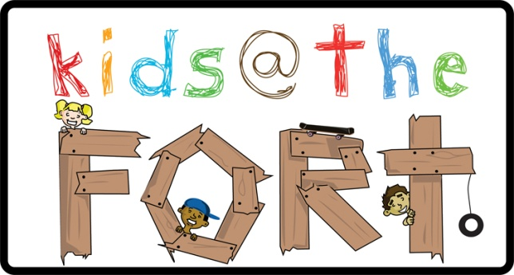
Living Waters Church: ARTS ort 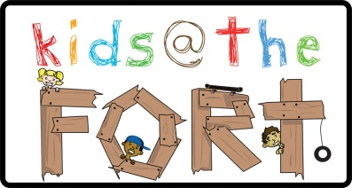 ARTS CAMP July 6 - 9, 2015
Camper Additional Information, Waiver and Medical Release Form
I give permission for my child ____________________________ to attend ARTS CAMP 2015.
Camper’s Birth Date: _____/_____/______ Grade going to:_______ T-Shirt Sz_________
Camper’s Address: ___________________________________________________
City: __________________________________ Postal Code: ___________________
Home #: ______________________________ Cell #: _________________________
Parent/Caregiver Email: _____________________ Can we contact you about upcoming events? Y / N
Provincial Health Insurance Number: ________________________________________________
Does your child have any severe allergies? (Bee stings, food) ________Yes _________ No
If yes, please explain: _______________________________________________________________
Does your child have any physical, emotional, mental or behavioural concerns or limitations that our staff should be aware of? _________Yes _________ No
If yes, please explain: _______________________________________________________________
Emergency Contact Name: ______________________________ Phone #: __________________
I give permission for the reasonable use of pictures containing my child. Y /N
Parent/Caregiver Name: __________________________ Signature: _______________________
Arts Camp specializes in Drama, Arts and Crafts, and the art of Baking!
The children will also have opportunities for activity times, which
include Team Time and kids devotionals.
Drop off and Pick up will be at Living Waters Church.
Date: July 6th – July 9th
Time: 10am-3pm
lunch break at noon, please bring a bag lunch.
Where: Living Waters Church,
9095 Glover Road, Fort Langley.
Age: entering grades 1-6.
Cost: $40.00
Cheques can be made out to Living Waters Church
(space is limited to 60 kids)
Please plan to attend the Arts Show on Thursday July 9th
from 6:30-7:45. All children will be involved.
Donations from the Art Show will benefit
?
Registration begins May 2nd . To register please bring in the attached form and payment to Living Waters Church on Saturday May 2nd from 10am – 12pm. It will be on a first come first served basis.
If you have any questions, please contact
Dee-Ana at 604-888-3330 or dgoodman@lwchurch.ca.

(Hosted by K@TF at Living Waters Church)
Please indicate one friend you would like to be in a group with: .
Information received is confidential and is being gathered for the purpose of serving your child while in the care of Living Waters Church. Precautions are taken for the safety and health of your child, but in the event of accident or sickness, Living Waters Church, its staff and volunteers are hereby released from any liability.

